**Md Sharif Hossain**

**1712336642**

**ENG 111.7**

**Sharif.hossain02@northsouth.edu**

**SATELLITE RADIO**

**INTRODUCTION**

**Attention Getter:** We all have used or heard about radio stations that we preset into our car radios or we use in our mobile phones. Some radio signals can only travel about 30 or 40 miles from their source or some might have a range of more than 22,000 miles. Have we ever imagined what these Radios are? Or how these radio systems work worldwide? Who maintains this system? Or how it is controlled in Bangladesh?

**Importance to Audience/Listener relevance link:** Satellite Radio is a new multi-billion technology of the 21st century. In this speech, I am going to deliver detailed information about Satellite Radio including the methods and services of it so that you can use that information for your own benefits.

**Thesis Statement:** Satellite radio is a type of digital broadcast, which transmits audio signals over large areas with greater clarity and consistency than conventional radio or FM radio.

**Preview:** I will discuss what Satellite Radio is, who gives the service around the world and how the process is done, and the procedure to establish a satellite radio channel in our country.

**(Transition: To start off, I will explain what Satellite Radio is.)**

**BODY**

I. **First Main Point:** According to Encyclopedia and as I have mentioned before, “**Satellite radio** is a type of digital broadcast, which transmits audio signals over large areas with greater clarity and consistency than conventional radio.”

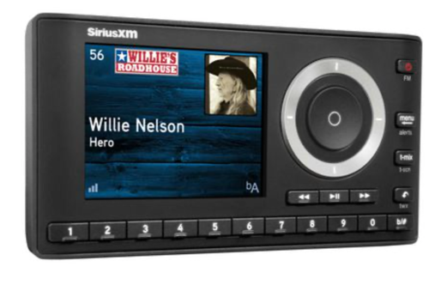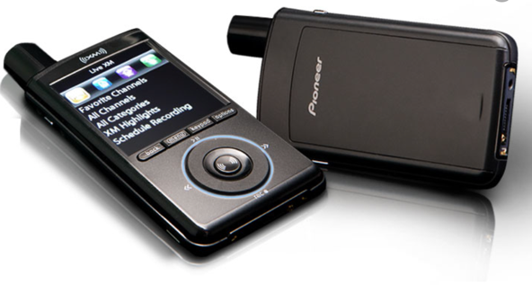

Fig: Car satellite radio and personal satellite radio

A. **Subpoint: General operating Range of a satellite radio:** Satellite radio is a paid radio service that can broadcast its signal from more than 22,000 miles or 35,000 kilometers away and then come through on your car radio with complete clarity. That means you could drive from Dhaka to France without ever having to change the radio station!

B. **Subpoint:** **Short history of Satellite radio:** The first satellite radio broadcasts occurred in Africa and the Middle East in 1999.

There have been three major satellite radio companies: WorldSpace, Sirius Satellite Radio and XM Satellite Radio, all founded in the 1990s in the United States. Of the three companies, **WorldSpace** went bankrupt in 2009 and Sirius and XM merged in 2008 to form **Sirius XM.** The merger was done to avoid bankruptcy.

C. **Subpoint:**

**1. Kinds of radios:** There are three famous types of radios. Those are: AM/FM radio,  [digital television radio](https://en.wikipedia.org/wiki/Digital_television_radio) (DTR) and Satellite Radio

**2. Difference between Satellite radio and FM radio**: There are some basic differences between satellite radio and AM/FM Radio. Let's have a look over some of the differences.

|  |  |  |
| --- | --- | --- |
| **Radio Format** | **Satellite** | **AM/FM** |
| **Monthly Fees** | Around US$10.99 and up | Free |
| **Portability** | Available | Prominent |
| **Listening availability** | Very high—a satellite signal's footprint covers millions of square kilometers. | Very low when compared to satellite radio. Around 30-40 miles from the station |

**(Transition: Next, I will talk about who gives the service around the world and how the process is done around the world)**

II. **Second Main Point**:

1. **Subpoint: Satellite radio service providers around the world. (With some interesting info like how much satellites each company owns, their total portfolio, a small joke on comparing their satellite launching cost and ours.)**

At this time, there are two space-based radio broadcasters: **Sirius XM Radio** and **1worldspace.**

Satellite radio companies are comparing the significance of their service to the impact that cable TV had on television 30 years ago. Satellite radio works a lot like satellite TV -- you purchase a receiver and pay a monthly subscription fee for a certain number of channels.

As of March 2013, SiriusXM had 24.4 million subscribers. This was primarily due to the company’s partnerships with automakers and car dealers. Roughly 60% of new cars sold come equipped with SiriusXM, and just under half of those units gain paid subscriptions. The company has long-term deals with General Motors, Ford, Toyota, Kia, Bentley, BMW, Volkswagen, Nissan, Hyundai and Mitsubishi.

As of May 2017, there are five **satellites** in orbit: two **XM** and two **Sirius satellites** and one spare all owned by Sirius XM. 1worldspace operated two satellites: AfriStar and AsiaStar.

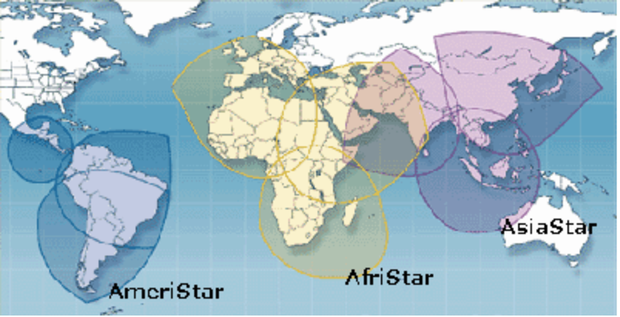

Fig: Area covered by satellites of 1WorldSpace

The interesting thing is, those 8 satellites took an average cost of 150 million USD which is far lower than the Bangabandhu satellite project which ended up with a cost of 250 Million USD.

B. **Subpoint:** Key components of satellite radio systems are:

1. **Satellites:**

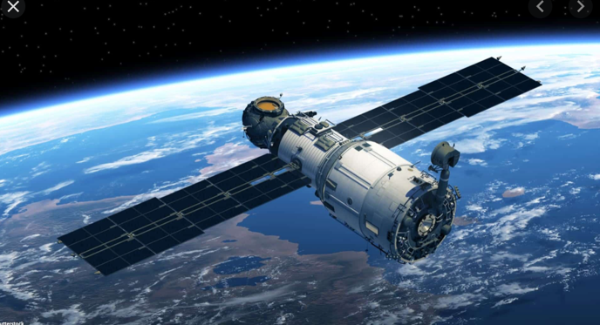

Fig: A satellite

1. **Ground repeaters:**

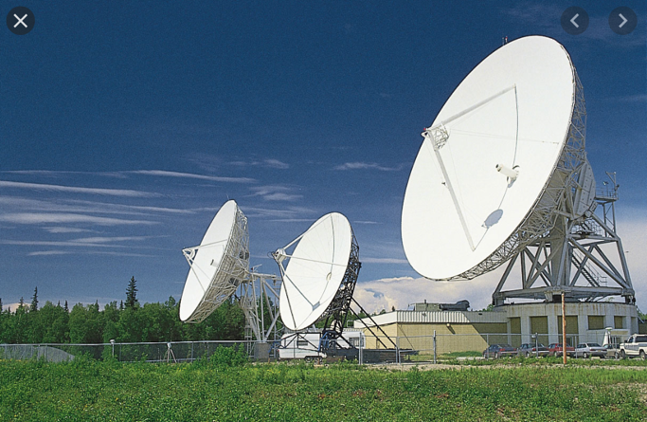

Fig: Ground repeater antenna

1. **Radio receivers:**

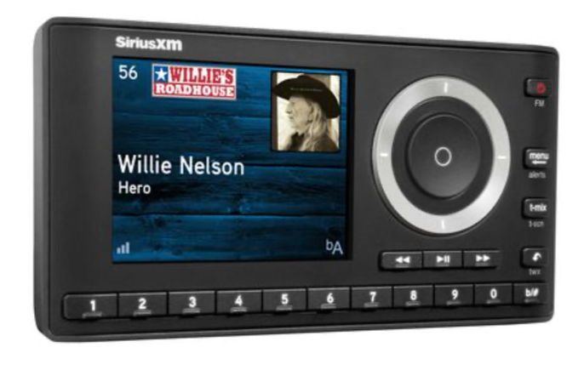

Fig: radio receiver

**C. Subpoint:** **Process of how Satellite radio works (With a diagram)**

Satellite radio subscribers purchase a receiver and pay a monthly subscription fee to listen to programming. They can listen through built-in or portable receivers in automobiles; in the home and office with a portable or tabletop receiver equipped to connect the receiver to a stereo system; or on the Internet. Ground stations transmit signals to the satellites which are 35,786 kilometers (22,236 miles) above the Equator in Clarke belt orbits. The satellites send signals back down to radio receivers in cars and homes. In urban areas, ground repeaters enable signals to be available even if the satellite signal is blocked. Let’s see the process in a simplified diagram:

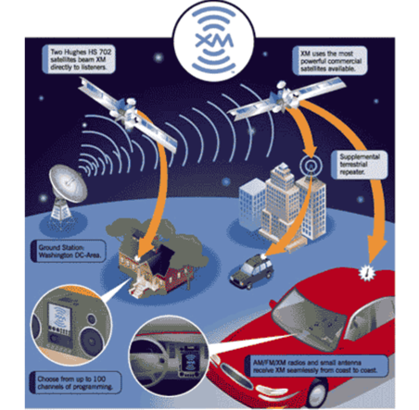

Fig: working process of a satellite radio

**(Transition: Finally, I will discuss the procedure to establish a satellite radio channel in our country)**

III. **Third Main Point:** Bangladesh Telecommunication Regulatory Commission (BTRC) controls the licensing of all Satellite radio channels in Bangladesh.

1. **Subpoint:** According to NFAP, frequency is assigned from BTRC to the licensee from **87.5 to 108** MHz.

B. **Subpoint:** Process of licensing

The license of FM radio/Community radio broadcasting is given from the Ministry of Information to establish and operate radio stations under private ownership.

After awarding license from MoI, licensee(s) shall have to apply for assigning frequency and to import Earth Station and SNG/DSNG equipment to BTRC. After assigning a frequency to the licensee, the licensee will eligible to import radio equipment by getting prior permission from BTRC.

The application format and list of necessary documents could be found in the website of BTRC.

C. **Subpoint:** **Future of Satellite radio in Bangladesh:** The major customers of satellite radios are car and ship companies, long-distance travelers and military persons. Bangladesh is currently a developing country. But there are no car manufacturing companies yet. Also, it's a very small country. So, FM radio plays a sufficient role in radio communication in this country. As a result, there is hardly a potential market for satellite radio in Bangladesh.

**(Transition: In conclusion)**

**CONCLUSION**

**Summary Statement**: Finally, Satellite Radio is a multibillion technological service of the 21st century which is famous for transmitting audio signals over large areas with greater clarity and consistency than conventional radio or FM radio.

**Concluding Remarks:** The funny thing is that, at its core, radio is an incredibly simple technology. With just a couple of electronic components that cost at most a d­ollar or two, you can build simple radio transmitters and receivers. The story of how something so simple has become a bedrock technology of the modern world is fascinating!

**(strong clincher: I can’t find any. Please help me out on it)**